Advanced Machine Learning: Programming Assignment 2 Report

-- Utsav Basu (20CS30057)

# Part 1: Gibbs Sampling

Gibbs Sampling was performed on the given distribution, to generate N = 10,000 samples. The obtained graphs are given as below:

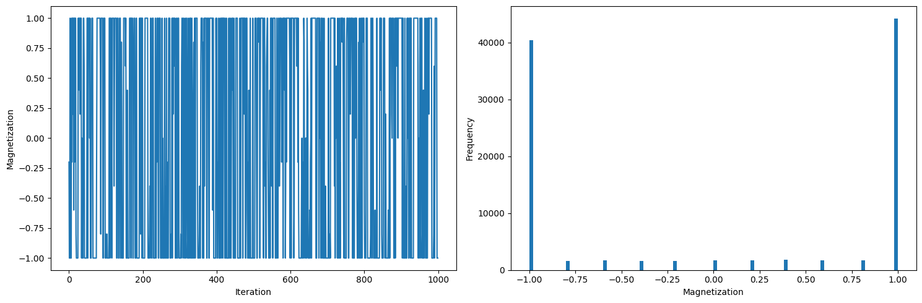

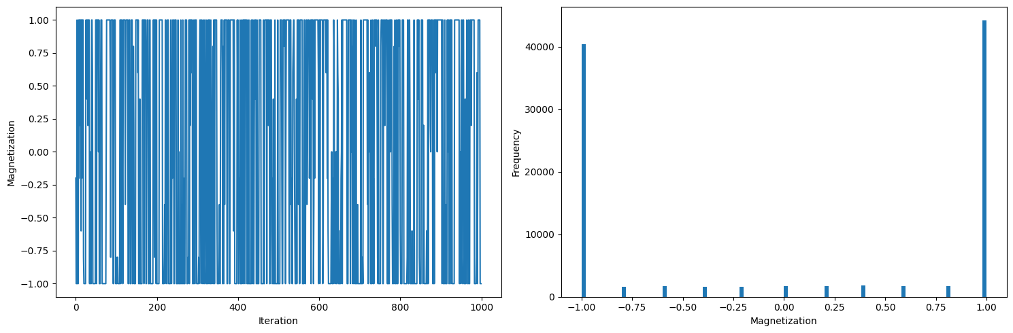

We observe that there’s a spike in magnetization values of -1 and +1. Frequency of the rest is low.

# Part 2: Metropolis-Hastings Algorithm

Metropolis-Hastings sampling was performed on the given distribution, taking the proposal distribution to be $Bernoulli(θ)$. The obtained graphs for $θ=0.5$ is shown below.

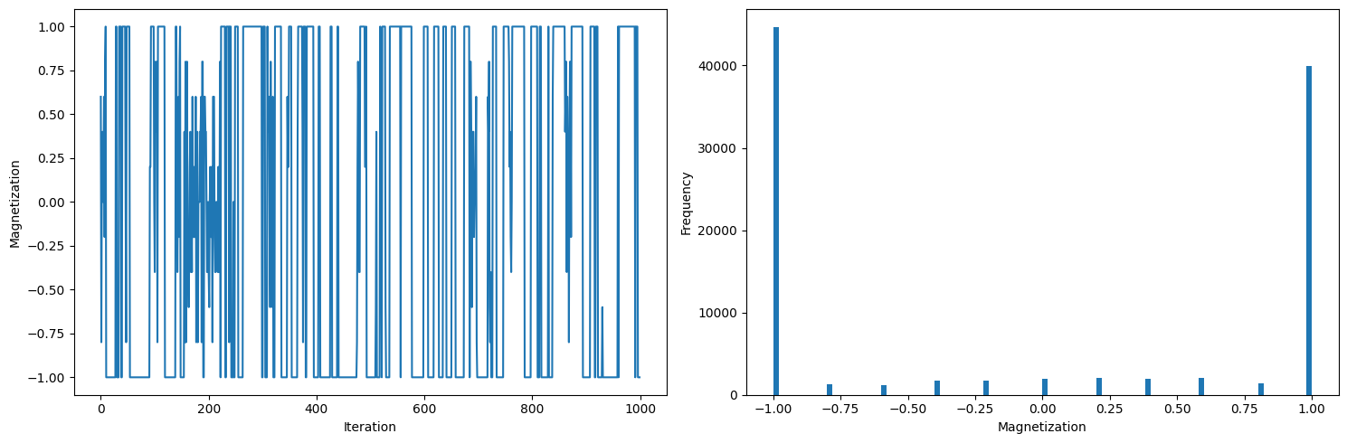



We observe, yet again, the there’s a spike in magnetization values of -1 and +1. Frequency of the rest is low.

MH sampling was performed on a number of $θ$ values. Rest of the graphs are there in the accompanying Jupyter Notebook. From the graphs we observe that the magnetization vs frequency graphs are similar for all $θ$ values. However, the iteration vs magnetization graph is showing us, that for low $θ$ the magnetization samples change frequently with each iteration, while for higher values of $θ$, the magnetization doesn’t tend to change so frequently.